WEIGHT WATCHERS FREESTYLE FOODS LIST FOR THE DOLLAR TREE
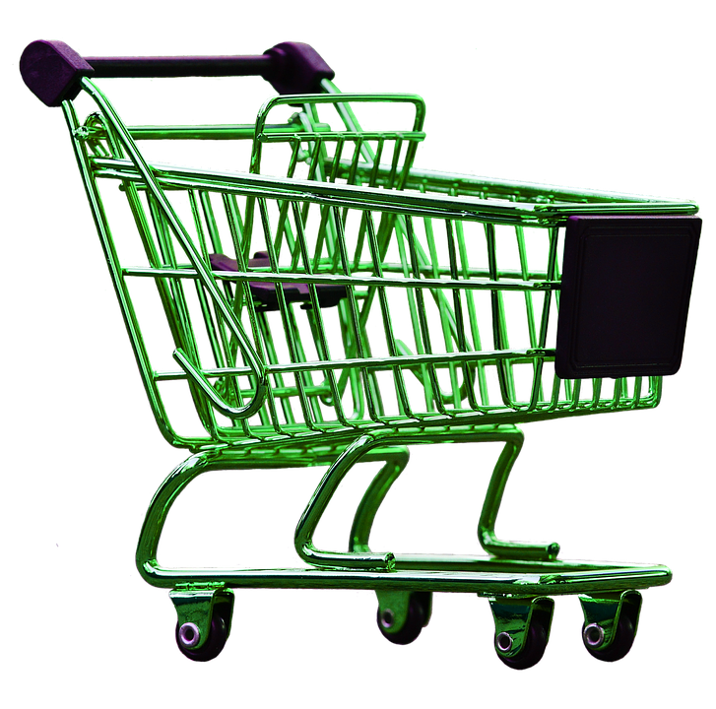
- Sweet Mate Sugar Substitute (0 Points)
- Nature’s Own Butter Bread (3 Points for 2 Slices)
- Munch Rights Veggie Puffs (4 Points for 40 Puffs)
- Snyder’s Mini Pretzels Value Bag (1 Point for 1 Bag)
- Snack Factory Pretzel Crisps (3 Points for 10/11 Crisps)
- Pampa Extra Long Asparagus Spears (0 Points for Entire Can)
- Chicken of the Sea/StarKist Tuna in Water (0 Points for Entire Can)
- Camillios 7” Pizza Crust (2 Pack) (8 Points for 1 Crust)
- 4C Japanese Plain Panko Bread Crumbs (3 Points for ½ Cup)
- Snack Pack Sugar Free Juicy Gels (0 Points for 1 Cup)
- Progresso Soup Cans Vegetable/Broth Based (3 Points for 1 Can)
- Healthy Choice Chicken Noodle Soup (3 Points for 1 Can)
- Kendall Farms Chicken/Beef Broth 32oz (0 Points for Entire Package)
- Goya Canned Black/Red/Chick Peas/Pinto Beans (0 Points for Can)
- Libby’s Whole White Potatoes (6 Points for 15oz Can)
- Libby’s Carrots/Green Beans/Mixed Vegetables/Peas/Beets/Corn (0 Points for 15oz Can)
- Rotel Diced Tomatoes & Green Chilis (0 Points for Entire Can)
- Pictsweet Frozen Vegetables (0 Points for Package)
- Jennie-O Turkey Burger 85%/15% (6 Points for 1 Patty)
- Rock Star/Rip It Zero Calories Energy Drinks (0 Points for 1 Can)
- Werther’s Original Sugar Free Caramel Coffee Hard Candies (1 Point for 5 Pieces)

