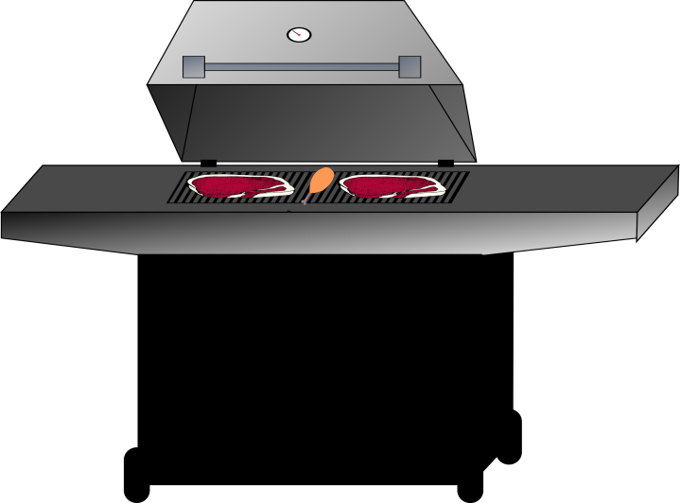

Produce Meat Fish

2 Red Peppers 3 lb Chicken Cutlets 2 lb Large Shrimp
1 Yellow Pepper 3 lb Scallops
1 Orange Pepper
1 Green Pepper Baking
3 Jalapeno Peppers
5 Red Onions Sliced Almonds
2 Garlic Heads
2 Bags of Salad Mix Dairy
2 Jicama
1 Head of Cauliflower 2 Quarts of Fat Free Greek Yogurt (Fage Preferred)
4 Large Zucchini (Green) Pint Fat Free Sour Cream
1 Large Cucumber Skim Milk - Quart
6 Plum Tomatoes Athenos Fat Free Feta Cheese
10 Green Onions 2 Bags of Kraft Fat Free Shredded Cheddar Cheese
1 Watermelon (Seedless) 1 Bag of Kraft Fat Free Shredded Mozzarella Cheese
Pint Blueberries (If Fat Free not available get reduced fat cheeses)
2 Limes I Can’t Believe It’s Not Butter Spray
10 Peaches
Mint (if using)

Snack Dry Goods

Pepperidge Farm Cinnamon Goldfish Balsamic Vinegar 2 Cans of Shoepeg White Corn
Can of Tomato Sauce 1 Can of Mexicorn
Lime Juice Lemon Juice
2 Cans of Black Beans 2 Cans of Pineapple Tidbits in Water

Pantry

Vegetable Cooking Spray Red Pepper Flakes Parsley Cilantro
Onion Powder Dill Weed Basil Splenda
Garlic Powder Dried Chives Cayenne Pepper Vanilla Extract
Paprika Salt & Pepper Cinnamon Almond Extract

